Grove - I2C Hub

(Redirected from [Twig - I2C Hub](http://www.seeedstudio.com/wiki/index.php?title=Twig_-_I2C_Hub&redirect=no))

|  |
| --- |
| **Contents**   [[hide](javascript:toggleToc())]   * [1 Introduction](http://www.seeedstudio.com/wiki/index.php?title=Twig_-_I2C_Hub#Introduction) * [2 Features](http://www.seeedstudio.com/wiki/index.php?title=Twig_-_I2C_Hub#Features) * [3 Application Ideas](http://www.seeedstudio.com/wiki/index.php?title=Twig_-_I2C_Hub#Application_Ideas) * [4 Cautions](http://www.seeedstudio.com/wiki/index.php?title=Twig_-_I2C_Hub#Cautions) * [5 Usage](http://www.seeedstudio.com/wiki/index.php?title=Twig_-_I2C_Hub#Usage) * [6 Resources](http://www.seeedstudio.com/wiki/index.php?title=Twig_-_I2C_Hub#Resources) * [7 Support](http://www.seeedstudio.com/wiki/index.php?title=Twig_-_I2C_Hub#Support) |

Introduction

I2C Hub Grove is an extension Grove module for connecting multiply I2C devices to Grove Base Shield. It can use with [Universal 4 Pin to X2 4 Pin cable](http://www.seeedstudio.com/depot/universal-4-pin-to-x2-4-pin-cable-5-pcs-pack-p-847.html?cPath=178_179) and connects up to 7 I2C divices which may cover most developing purpose.

**Model:**[**ACC53133P**](http://www.seeedstudio.com/depot/grove-i2c-hub-p-851.html?cPath=178_191)

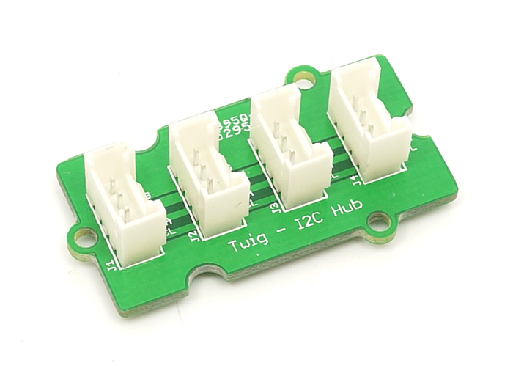

Features

* Chainable

Application Ideas

* Using more I2C devices than you otherwise have room for on your Grove platform

Cautions

When building this from scratch, take care to mount the sockets properly to avoid shorting out a device. You should use keyed sockets to prevent reverse installation.

Usage

It does not conflict if use I2C Socket simultaneously because every I2C device has its own address.br<>Hardware Installation as show below:

Here we do not listed specific examples.

Resources

[I2C Hub Eagle File](http://www.seeedstudio.com/wiki/File:I2C_Hub_Eagle_File.zip)

Support

If you have questions or other better design ideas, you can go to our [forum](http://www.seeedstudio.com/forum) or [wish](http://wish.seeedstudio.com/) to discuss.